JBoss Installation and configuration
Version 1.0
Date 01/11/10

Copyright notice
Copyright © 2010, Cognizione consulting & solutions Pvt Ltd
All rights reserved.

These materials are confidential and proprietary to Cognizione consulting & solutions pvt
ltd/its licensors and no part of these materials should be reproduced, published, transmitted
or distributed in any form or by any means, electronic, mechanical, photocopying, recording or
otherwise, or stored in any information storage or retrieval system of any nature nor should the
materials be disclosed to third parties without the prior express written authorization of
Cognizione consulting & solutions Pvt ltd/its licensors
Revision history

Doc No: | Version no. | Change reference no. | Author | Published date | Sections changed | Description of changes
 |  |  |  |  |  | Base Document

Purpose of the document 4
Scope of the document 4
Desired outcome 4
Targeted recipient 4
Prerequisite 4
Required Software 4
Installation of JBoss Application Server 5
Configuration of JBoss Application Server 6
Verifying JBoss installation 8

Purpose of the document

To demonstrate the following

- Installation of JBoss.
- Configuration of JBoss Application Server.

Scope of the document

This document is all about how to JBoss services and their maintenances for window based systems. It doesn’t cover the following points.

- How to install/uninstall JBoss as a service
- Configuring services to pass different parameters at service startup

Desired outcome

It is expected that after going through this document the reader will be proficient in the following

- Installing JBoss.
- Configuring JBoss.

Targeted recipient

- Developers working with JBoss AS

Prerequisite

- Knowledge of Application Server.

Required Software

Following Softwares are required for this tutorial

- JBoss AS 5.0.1 ( downloadable from http://www.jboss.org/jbossas/downloads.html ).

Installation of JBoss Application Server

The JBoss Application Server , version 5.0.1 can be downloaded from the following URL http://sourceforge.net/projects/jboss/files/JBoss/JBoss-5.0.1.GA/

At the time of this writing the above mentioned URL will display a page something like shown below.

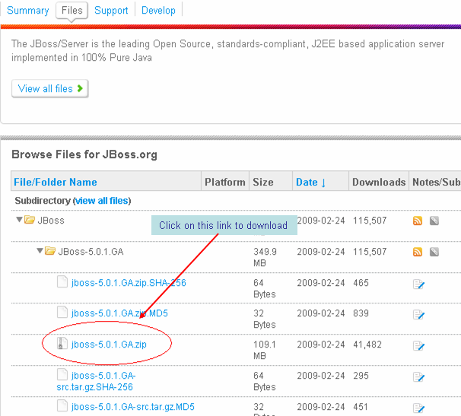

Once the page is opened , follow the steps mentioned below

- As shown in the above figure, click on the link “jboss-5.0.1 GA.zip”.
- Save the zip file in your machine. The downloading may take a while as the size of the file is 109.1 MB.

Once the file download is complete, you can install JBoss. The installation of JBoss is simply a matter of extracting the compressed archive to any location in your machine.

Configuration of JBoss Application Server

The installation of JBoss, as mentioned in the preceding section, is quite straightforward. But after installation, JBoss needs to be configured which is done as described below

- Open up the “System Properties” window and then the “Environment Variables”, as explained in the section Configuration of JDK.

- Create a new user variable under the “User Variables” window – “JBOSS_HOME” with variable value set to the path where you had extracted JBoss. Assuming you had extracted it to a folder “D:\JBoss”, type “D:\JBoss” under variable value field, as shown below

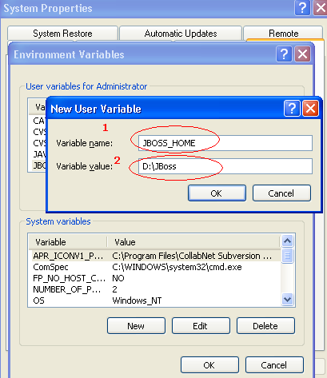

- Click on “OK” to close the popup window.

- Next, double click on the “Path” variable under “User Variables” section and append the following line – “%JBOSS_HOME%\bin”, as shown in the figure below.

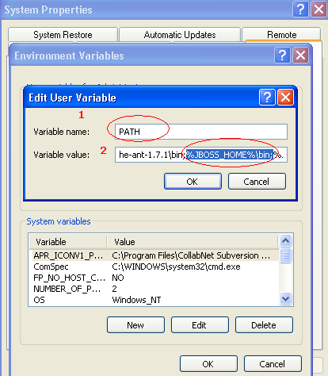

- Click on “OK” to close the popup window and then click “OK” on the “Environment Variables” window and then finally click “OK” on the “System Properties” window.

The above steps will configure JBoss Application Server in your machine. The installation and configuration can be verified as described in the next section.

Verifying JBoss installation

To verify that JBoss Application Server is installed properly it is wise to perform a simple startup test to validate that there is no problem with your JDK/ operating system combination. To test JBoss follow the following steps.

- Open command prompt, on the machine in which JBoss Application Server is installed.

- Type “run –b 0.0.0.0” , and press enter as shown below.

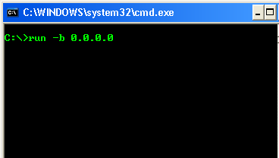
Figure 1:- Command to start JBoss Application Server.

- Wait till the message ,“ Server Started in…” message comes in the console as shown below.
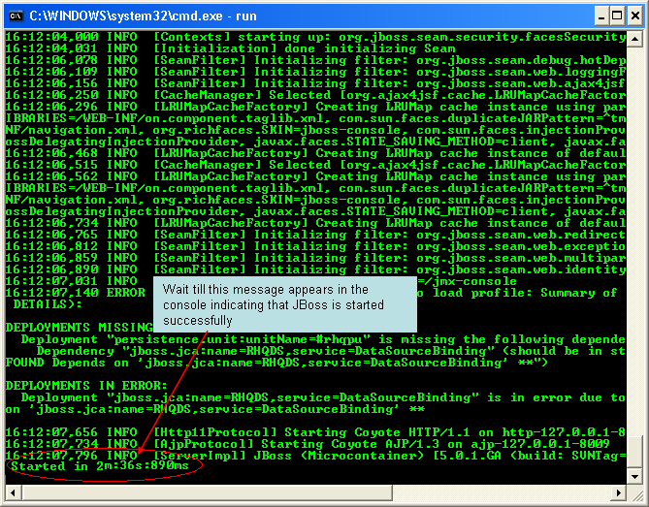
Figure 2 :- Console window when JBoss is started successfully

- This process may take a while depending on the server configuration and may vary from machine to machine.
- Once JBoss is started, open any browser window in the same machine and point your browser address to http://127.0.0.1:8080/ . (The IP address can be replaced by “localhost” and 8080 is the port in which JBoss is installed. If your port number is different then use that port number.)

- This should open the JBoss Console in the browser as shown below which indicates that JBoss is installed properly.

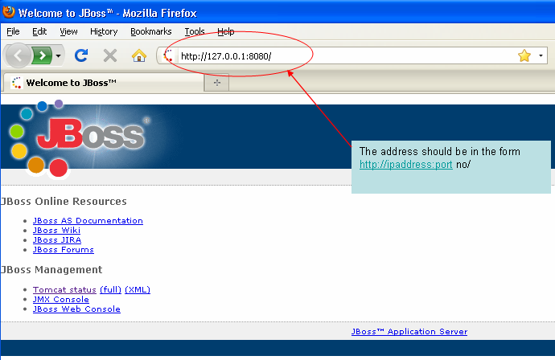
Figure 3 :- JBoss Console from browser. Displaying of this page indicates that JBoss is installed properly.

